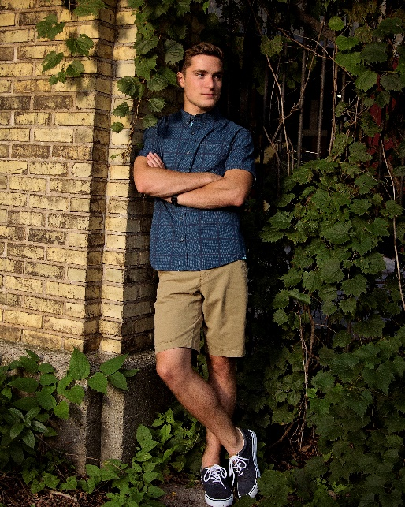
Hello my name is Brock Kovacic and currently a senior attending South high school. I am a level 8 competitive gymnast from Sheboygan YMCA coached by Denice Nugent. During high school I have also participated in Soccer, Track and Field, and Dive, and after graduation I am attending UW-Madison to continue Pole Vault.
I have gone on two mission trips in Kentucky for the Appalachian Service Project and going on my third this year
Favorite Food: grilled chicken
I was the 2018 YMCA state champion

Favorite Gymnastics event/skill: High bar
Thank you to everyone who supported me through these many years
Favorite color: orange

