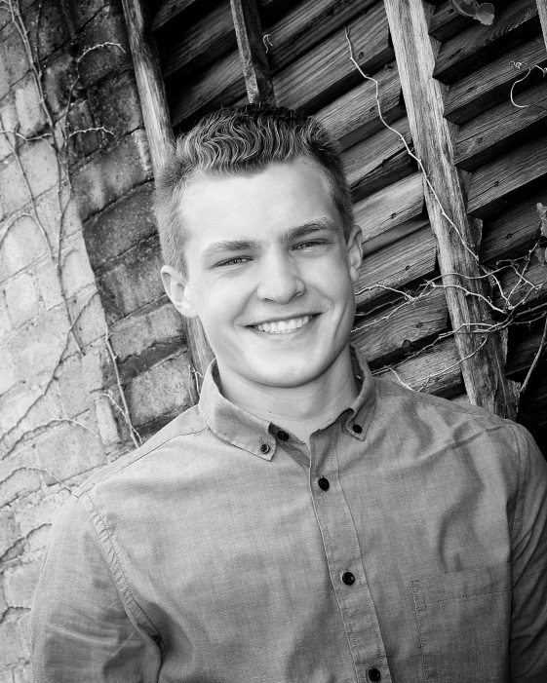

Hello my name is Charlie Richards, and currently a senior attending Oshkosh West high school. I am a level JD competitive gymnast from Oshkosh WI coached by Joe Cuadra. During high school I have also participated in all four years of the choir musical and earned my Eagle Scout. After graduation I hope to earn my degree in automotive mechanics and join the Air Force.
Interesting life story ………… I had hernia surgery the first day of summer vacation after my sophomore year. The next day I was out for a recovery walk and I was attacked from behind by the neighbor’s Pitbull. I was taken to the hospital with bite marks in my back, leg and forearm. The owner was so drunk he didn’t know his dog had attacked someone. Unfortunately, the lawyer was not able to recoup any financial payments.
Favorite Food: Chicken
Gymnastics accomplishments…Double back dismount on rings which I accomplished after a year off from a shoulder injury.
Favorite Gymnastics event/skill: I really enjoy the rings and my favorite skill is doing a double back on rings or a full twist off rings.
Ending Salutations………..I have been at Oshkosh Gymnastics Center since I was 9 months old. I have wonderful memories and have made great friendships while at OGC. I greatly appreciate the wonderful coaches I have had in my years at the gym, the skills they have taught me, their mentoring and their friendship.
Favorite color: Blue

