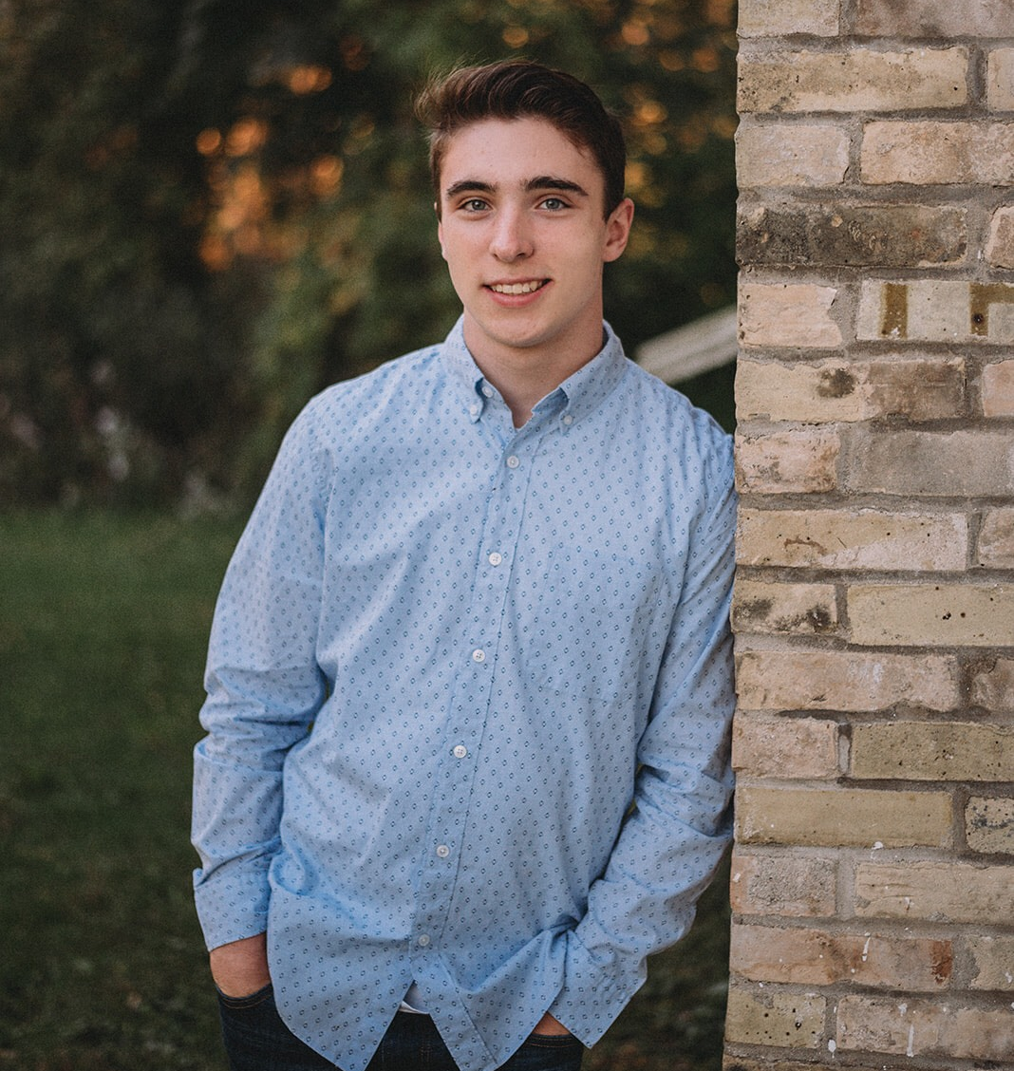
Hello, my name is Cole Janz. I am currently a senior at Muskego High School. I am a level 10 competitive gymnast from M&M Gymnastics coached by Brad LeClair. During high school, I have also participated in the Build Moto Program where I built a motorcycle with classmates, a Boundary Waters church service trip, volunteered at Hunger Task Force, and a lifeguard and swim instructor at the Princeton Club. After graduation, I hope to continue my gymnastics career at the collegiate level and pursue a degree in physical therapy.
I started gymnastics because when I was very little I had low muscle tone in my upper body. That meant it was nearly impossible for me to do everyday tasks such as squeezing a toothpaste tube. Gymnastics was initially just a way for me to get stronger, but it turned into a way of life for me.
Favorite Food: mashed potatoes
In 2016, I was State champion in the All Around. I have qualified to three JO Nationals so far and placed in the top 20 in the All Around two out of three of those years. I was also selected to compete for Region 4 at the Windy City meet this season.
Favorite Gymnastics Event: floor
Skill: full twisting double layout
I would like to thank Region 4 and men’s gymnastics for shaping me into the person I am today. And, a special thank you to my family, teammates, and coaches for being my biggest supporters on this journey.
Favorite Color: green

