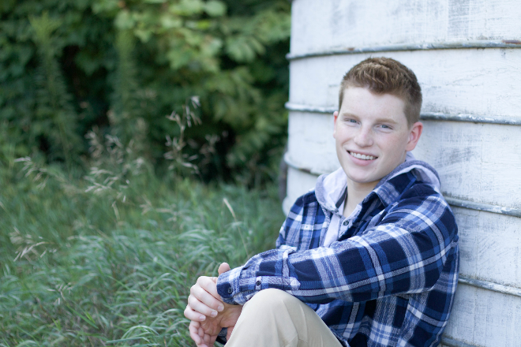
Hello my name is Jacob Biller, and I am currently a senior attending Saint Michael-Albertville high school. I am a level 10 competitive gymnast from Twin City Twisters coached by Drew Shields. During high school I have also participated in Spanish Club, Freshman Mentoring, and a volunteer with Special Olympics Minnesota. After graduation I hope to pursue a Pre-Pharmaceutical Degree at Temple University.
I started gymnastics when I was three years old as a way to release some energy. My parents were tired of me tumbling around the house and breaking everything in sight. I also was signed up for a t-ball program but quickly gave up a path of baseball because my mom did not like watching me build sandcastles in the dirt during the game. This so called “energy-release” plan backfired on my parents as I quickly fell in love with the sport and have competed ever since.. Gymnastics has given me many opportunities to travel; it’s allowed me to grow, and I know I would not be the person I am today without this crazy, difficult, and exciting sport.
Favorite Food: Sushi
I have had many accomplishments throughout my 15 years of competitive gymnastics. I have learned to overcome many physical and emotional setbacks due to injuries. In addition, I have qualified to nationals four times, qualifying to event finals in all four. I have placed top 12 on floor at every nationals, and placed 5th in 2013 and 7th in 2017. Gymnastics has given me many opportunities and lessons in order to become a strong and driven individual.
Favorite Gymnastics event/skill_Floor/Double-Double
I want to thank my coach, my family, and friends for always pushing me to be the best I can be, continued support, and helping me achieve all my aspirations over the years.
Favorite color Blue

