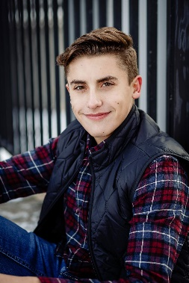

Hello my name is Zachary Irene, and currently a senior attending Sussex Hamilton High School. I am a level 10 competitive gymnast from Salto Gymnastics Center coached by Alex Belanovski, Andrei Kan, and Anthony Ingrelli. During high school I have also participated in my high school climbing club and after graduation I plan on attending college to study Civil Engineering.
Interesting life story …………
The hardest challenge I have had to face is fighting back after my knee injury. I have learned how to overcome obstacles, face my fears, and work through frustrations to reach my goals
Favorite Food Swedish Fish
Gymnastics accomplishments………
Four-time recipient of the Academic All American, Regional Champion in 2016, and Regional High Bar Champion 2017

Favorite Gymnastics event/skill:
High Bar/ Zou Li Min
Ending Salutations…………….
A special thanks to all of my coaches that have touched my life. A thank you to his teammates for your support, the push when needed, and always being there to support him.
Favorite color: Blue

