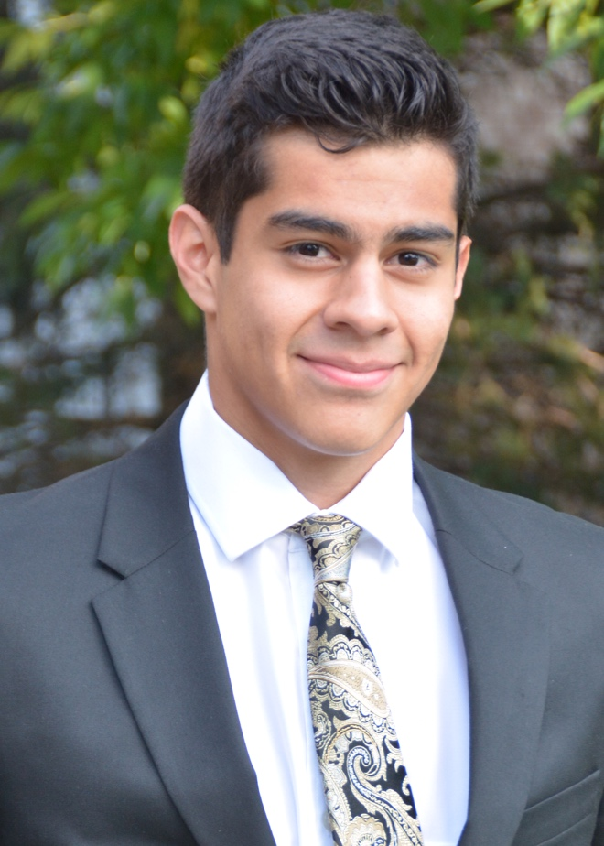

Hello my name is Thiago Xifra, and currently a senior attending Breck School. I am a level 10 competitive gymnast from Mini Hops Gymnastics in Minnesota coached by Doug Price. During high school I have also participated in Soccer and diving, and after graduation I hope to compete on a club team in college and study Mechanical Engineering.
Interesting life story …………
During my junior year of high school, I wanted to quit gymnastics. Shortly after, I also found out that I had ADHD. I ended up having the best year of my academic career and sticking with gymnastics, while also trying my hand at Diving. I want to thank all my teammates and my coach for being so understanding and helping push through that difficult time in my life.

Favorite Food Sushi
Gymnastics accomplishments………
I made nationals in 2016 and 2017, also made event finals at the John Roethlisberger meet in 2016 and 2019.

Favorite Gymnastics event/skill: Parallel Bars/ Gushikin
Ending Salutations…………….
Thank you to everybody that helped me and supported me all these years. I would especially like to thank my parents and my coaches for being so supportive when I wanted to quit and for encouraging me to push through. It means a lot to me to be able to say that I completed high school as a gymnast. Thank you!
Favorite color Black

