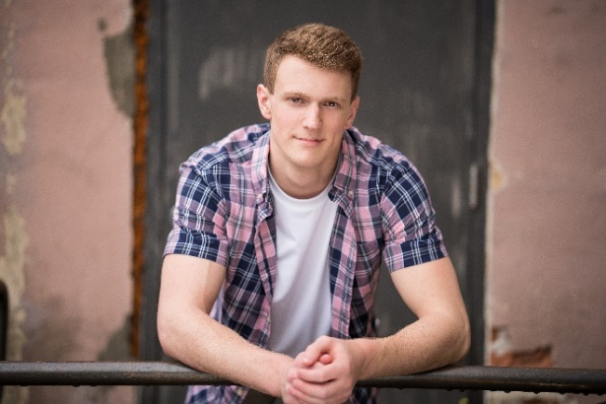

Hello, my name is Evan Van Aacken, and I am currently a senior attending Oshkosh West High School. I am a level 10 competitive gymnast and team captain from Swiss Turners Gymnastics Academy coached by AJ Sandberg. During high school I have also participated in Chorus, Junior Rotary, Leadership, and Yearbook. After graduation I would love to compete in collegiate gymnastics while majoring in Computer Science.
In an unexpected turn of events, in January 2017, I was diagnosed with testicular cancer. While recovering from surgery and undergoing chemotherapy, I competed at the Wisconsin State and the Regional IV Championships, qualifying for JO Nationals. At JO Nationals, I qualified for All-Around Finals, taking 42nd all while having a PICC line in my right arm and having gone through 3-rounds of chemotherapy! To date, all labs and CT scans have come back clear... NO cancer! Gymnastics did not cure my cancer, but with it and the support of my coaches and teammates, gave me the strength to kick its butt!
Favorite Food: Sushi
I started gymnastics at age 3 at the Oshkosh Gymnastics Center (OGC), in Oshkosh, WI, following in the footsteps of my older brother, Anthony. In October 2011, my head coach at OGC decided to move on, so my family made the hard decision to make the 86-mile commute to Swiss Turners Gymnastics Academy four to five times per week.
During the 2015 season, as a level 9 gymnast, I was the USA Gymnastics Junior Olympic National High Bar champion, placed 3rd on Vault, 8th All-Around (6 events), and won day 2 of All-Around Finals competition. I have also been champion: Region IV Vault in 2014 & 2015; Region IV High Bar in 2014; Wisconsin All-Around in 2010, 2012, & 2014; Wisconsin Floor in 2013 & 2015; Wisconsin Vault in 2011 & 2015; Wisconsin Parallel Bars in 2010, 2013, & 2016; and Wisconsin High Bar in 2010, 2012, & 2014.
Favorite Gymnastics event/skill: High-Bar/Kovacs
I, along with my parents, would like to thank MANY in our Gymnastics Family who have helped and supported us in so many ways over the years!
Favorite color: Sky Blue

