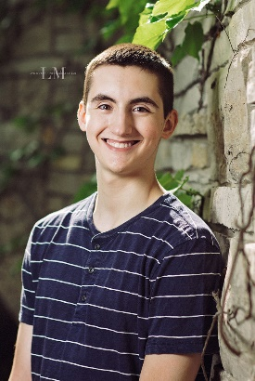
Hello my name is Wyatt Stimson, and currently a senior attending Sussex Hamilton High School. I am a level 10 competitive gymnast from LaFleur's coached by Jordan Sholtes. During high school I have also participated in my high school’s swimming and diving club and after graduation I hope to attend Iowa State for engineering.
In the last practice before regionals 2017, I got grip lock on high bar. It took me well over a year to recover. Through this, I have learned how to overcome obstacles, face my fears, and work through the difficulties to reach my goals.
Favorite Food: Fried Rice
In 2017 Wyatt was state champion in the All Around in level 9. I have progressed through the levels and learned how to persevere through injuries. I have had many injuries over the years and I have worked hard to get my head back in place and keep doing gymnastics.
Favorite Gymnastics event/skill: Pommel Horse/ circle
I would like to thank my coach Jordan Sholtes and every other coach I have had for the many hours a week of practice we have gone through, as well as always encouraging and teaching me. there is no sport better be a part of and I will never forget all those years I have spent at LaFleur’s.
Favorite color: Red

